Connecting to managed AWS services

A. How to connect to managed AWS services

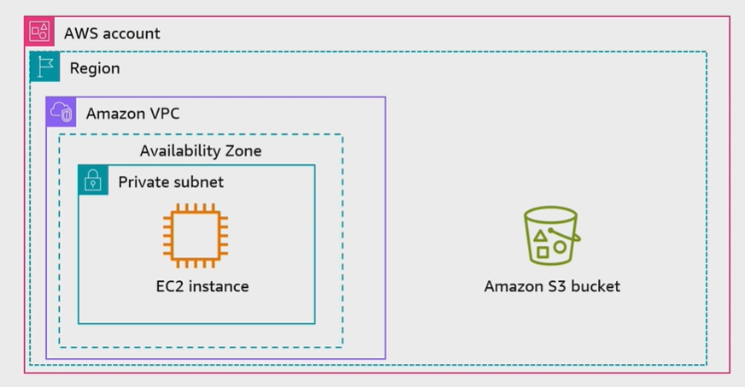

B. Interface VPC Endpoint
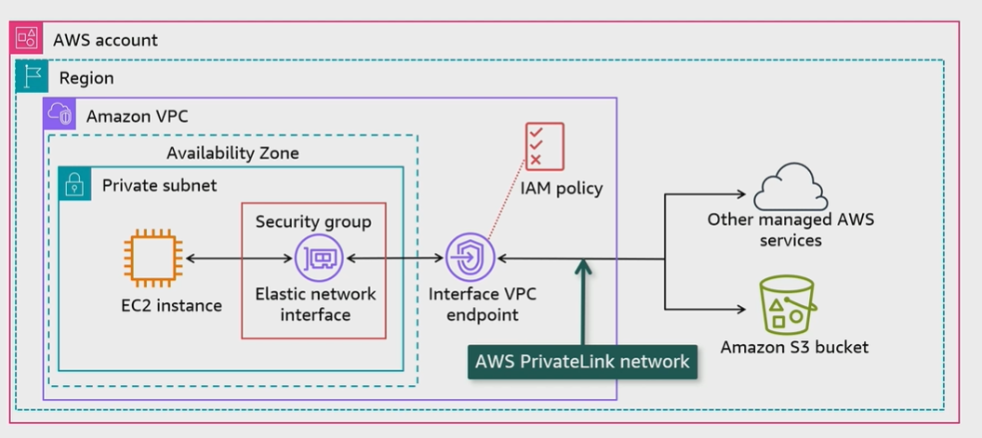

C. Gateway VPC Endpoint
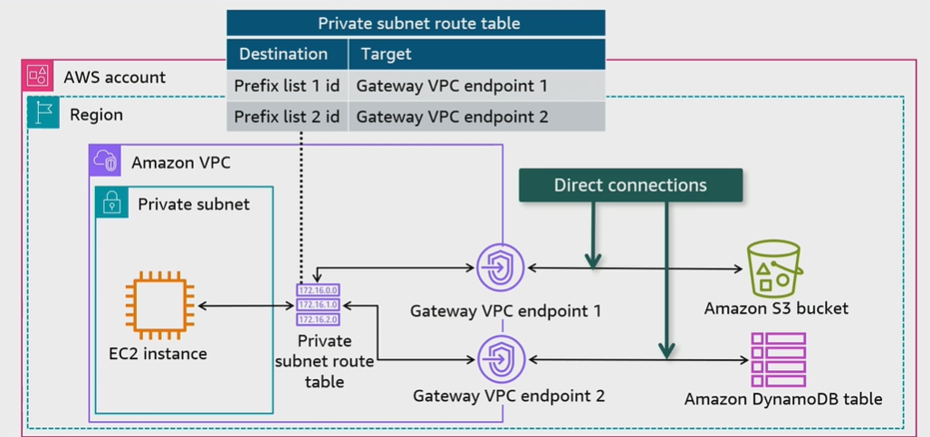
D. Amazon S3 endpoint considerations
Factor | Interface VPC endpoints | Gateway VPC endpoints
Amazon S3  Access point | Private IP addresses from VPC subnet | Amazon S3 public IP addresses
On-premises | Allow access | Do not allow access
Other AWS Region | Allow acces | Do not allow access
Cost | Billed | Not billed
Bandwidth | Bandwidth of up to 10 Gbps per AZ, and automatically scales up to 100 Gbps | No limit
Packet Size | Maximum packet size supported is 8500 bytes | No limit

E. Gateway Load Balancer endpoint
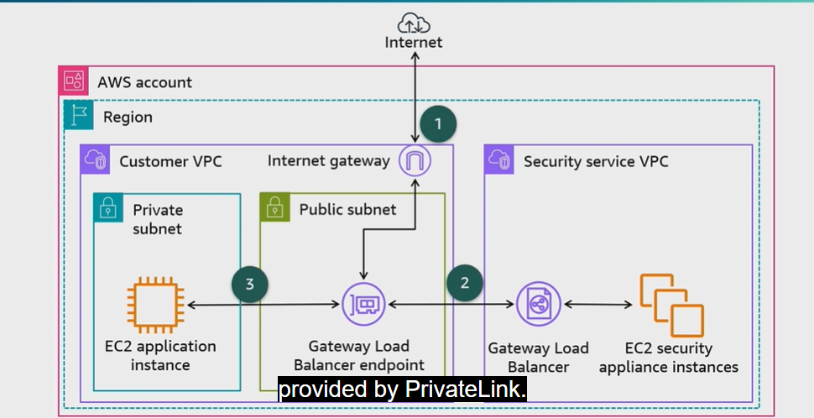
F. Conclusion
- VPC resources can access AWS managed services using VPC endpoints
- An interface VPC endpoint uses AWS PrivateLink to access AWS managed services which incurs cost and has througshout limitations
- A gateway VPC endpoint integrates directly with Amazon S3 and Amazon DynamoDB. It does not incur cost and has no throughput limitations
- Gateway Load Balancer endpoints are used with Gateway Load Balancers to inspect traffic with security appliances

